Nepal College of Information Technology
Unit Test
Fall 2010
Program: B.E. ELX Time: 2 hrs
Semester: Fall (I) FM: 70
Subject: Control Systems PM: 35
1. a) Define open loop and closed loop system with suitable examples. Which system is more reliable to operate? Explain with suitable reasons. [8]
b) The overall transfer function of a negative feedback system is given by
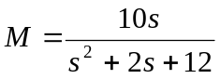
The feedback path transfer function is given by H(s)=1/s. Obtain the open loop transfer function G(s). [7]

2 a) A mechanical system is represented as shown in the figure below:
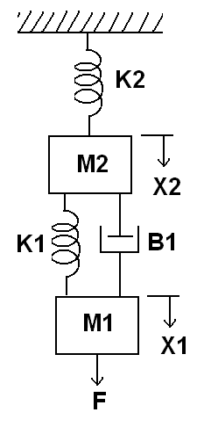
Obtain the mechanical equations and also draw the force voltage analogy and force current analogy of the given system. [8]
b) Write down the defining equation for the liquid level system shown in the below figure. Obtain their transfer function also. [7]
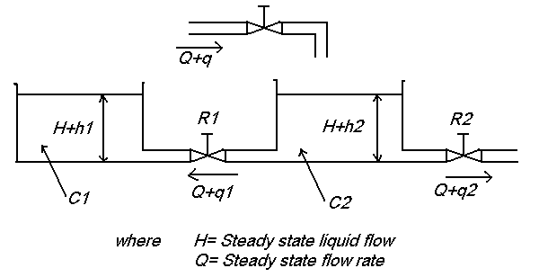
3 b) Draw the overall block diagram for field controlled DC motor. Also find the overall transfer function. [7]
b) Obtain the mechanical system for the electrical system shown in figure. [8]
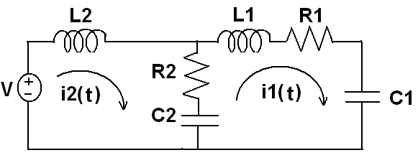
4. a) Obtain the overall transfer function of the system shown in the figure using signal flow graph technique [8]
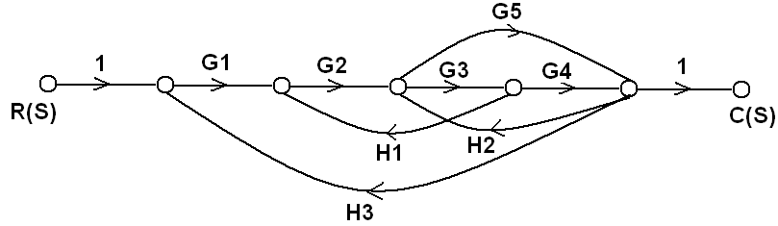
b) Determine the overall transfer function C(s)/R(s) for the system represented by the block diagram shown below. [7]
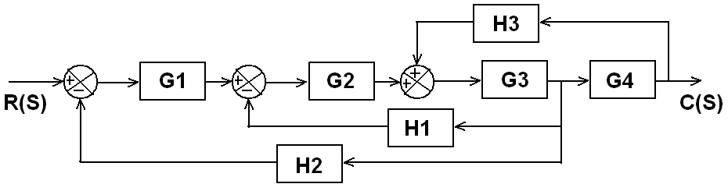
5. Write short notes on (any two) [5*2=10]
a) Linear approximation of non-linear system
b) Sensors
c) Human control system

